Appendix B. Parameter Screen Layouts

Fleet:

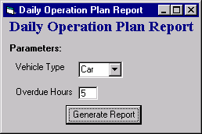
Daily Operation Plan Report

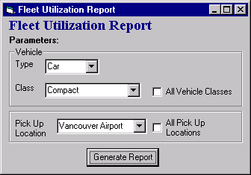
Fleet Mix Report

Fleet Turn Back Schedule Summary – Daily Report

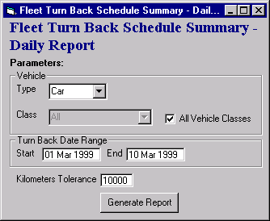

Fleet Turn Back Schedule Summary – Monthly Report
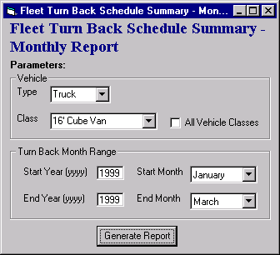

Foreign Vehicle Control Report
The following shows how the parameter screen would look in the following two situations:
- Select By selected as “Owning Company”
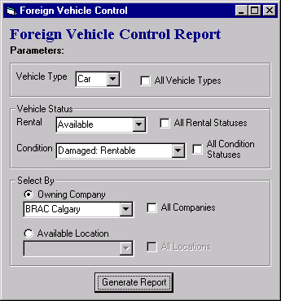
- Select By selected as “Available Location”

- Select By selected as “Owning Company”
- Select By selected as “Available Location”
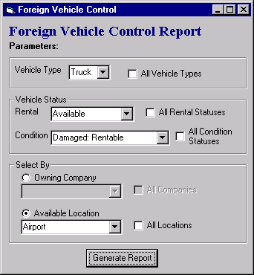

Missing Kilometers Report

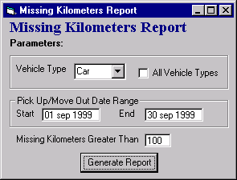

Units Available for Rent Report
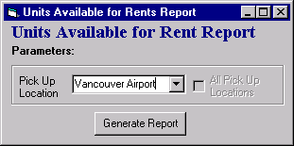

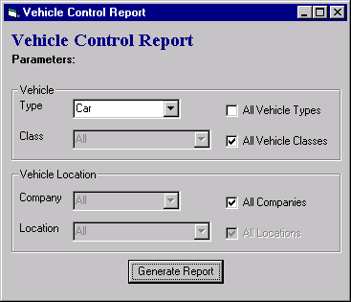
Vehicle Control Report

Vehicle Due Back by Hourly Report
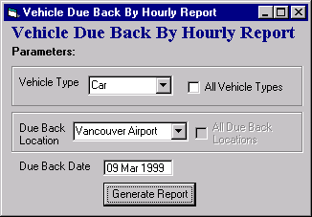

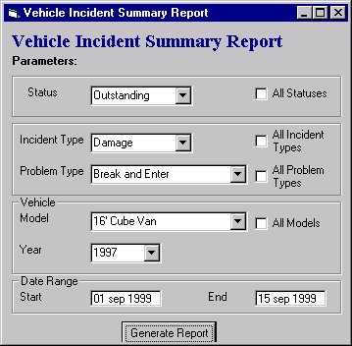
Vehicle Incident Summary Report

Vehicle Utilization 2 Year Comparison Report

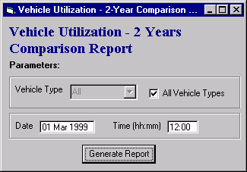
Vehicle Utilization Current Report
